MASS, WEIGHT, VOLUME & DENSITY REVIEW
Student Name: ________________________________________ Date: ________ Period_______
- The density of a substance equals its mass divided by its volume. Talia listed the density of some common materials at 20 °C.

Material | Density (g/cm³)
gasoline | 0.70
mercury | 13.6
milk | 1.03
water | 0.998

If Talia has 10 grams of each material, which material has the greatest volume?

 |  | A. | gasoline
 |  | B. | mercury
 |  | C. | milk
D. water

2. A metal coin has certain properties that can be measured. Which property of a coin is different on the moon than it is on Earth?
A. density
B. mass
C. volume
D. weight

Susie use3. Susie used a double-pan balance to measure the mass of an object by comparing it to a reference mass. She recorded the mass as 125 grams.

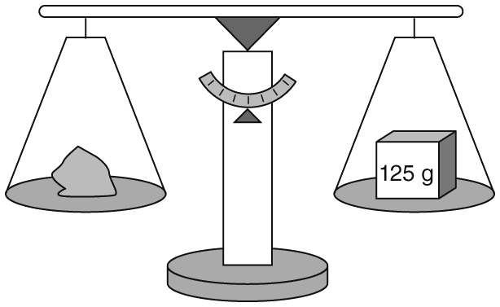

What value will Susie record for the mass of the object if she takes the same measurement on the moon, where the gravitational force is about one-sixth of Earth’s gravity?

A. | 0 grams
B. | 21 grams
C. | 125 grams
D. | 750 grams
4. Julio mea 4. Julio measured the mass of a small rock as 11.0 grams. Then he measured the volume of the rock as shown in the illustration below.

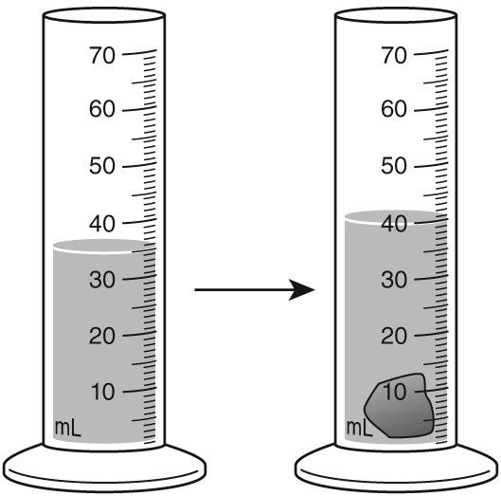

What is the density of Julio’s rock?

A. | 1.1 g/cm³
B. | 2.2 g/cm³
C. | 5 g/cm³
D. | 11 g/cm³

5. The grav 5. The gravitational force on Mars is about one-third that of Earth’s gravitational force. If a space probe has a mass of 300 kg and a weight of about 660 pounds on Earth, what would be the mass and approximate weight of this probe on Mars?

A. | mass = 100 kg, weight = about 220 pounds
B. | mass = 300 kg, weight = about 220 pounds
C. | mass = 300 kg, weight = about 660 pounds
D. | mass = 900 kg, weight = about 660 pounds

6. The den 6. The density of aluminum is 2.7 g/cm³. What is the volume of a piece of aluminum if its mass is 8.1 grams?

A. | 0.33 cm³
B. | 2.7 cm³
C. | 3 cm³
D. | 21.9 cm³
ty of
7. A piec 7. A piece of titanium has a mass of 18 grams. Using a graduated cylinder partly filled with water, a scientist found that the titanium displaced 4 milliliters of water. What is the density of titanium?

A. | 0.22 g/cm³
B. | 4.5 g/cm³
C. | 18 g/cm³
D. | 324 g/cm³
of titanium
The density 8. The density of a sample of gasoline is 0.70 g/cm³. What is the mass of 1 liter of this gasoline?

A. | 0.7 g
B. | 70 g
C. | 700 g
D. | 1,429 g
of a sample
9. Some properties are the same in a substance no matter the amount of the substance.
Which of the following characteristics does not change based on the amount of the
substance?

A. | mass
B. | volume
C. | density
D. | Weight
10. 10. Look at the activity shown in the figure below.

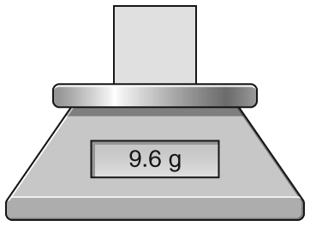

What property of matter is being measured in this activity?
A. | color
B. | mass
C. | shape
D. | texture
11.
11. The two beakers shown below contain pure water.

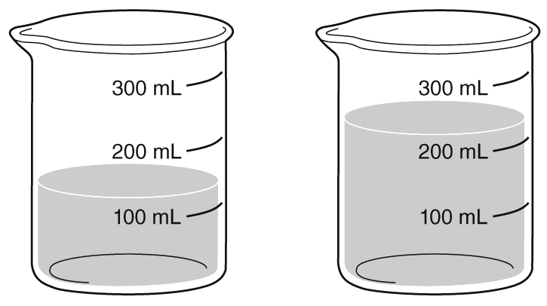
Which of these properties is the same for the water in both beakers?
 |  | A. | mass
 |  | B. | weight
 |  | C. | volume
D. density

12. Mass can be measure in units of ____________
  - grams
  - Newton
  - cubic centimeters
  - millimeters

13. The volume of a box is ___________
A. how much it weighs
B. how much space it occupies
- how much matter it contains
- how tall it is

14. Kiki attached a small, metal block to a spring scale and held the scale by the ring on top. She then recorded the weight of the block.

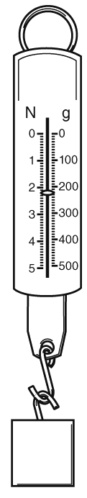

Which weight did Kiki record in her science notebook?
A. | about 2 Newtons
B. | about 2 grams
C. | about 2 ounces
D. | about 2 pounds
15. Amanda dropped a rock into a graduated cylinder containing water. The water level in the cylinder increased. Which property of the rock is this experiment designed to measure?

A. | density
B. | volume
C. | mass
D. | weight

